Working through solved? Function

**Examples**



**Template**

* A board is solved when everything is a Natural or
* A board is solved when there is no false value





**Code body**

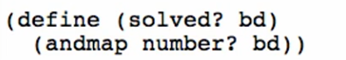

* A board is solved when everything is a Natural or
* A board is solved when there is no false value

Working through next-boards Function

**Examples**

Finds first empty square, fills it with Natural [1, 9]

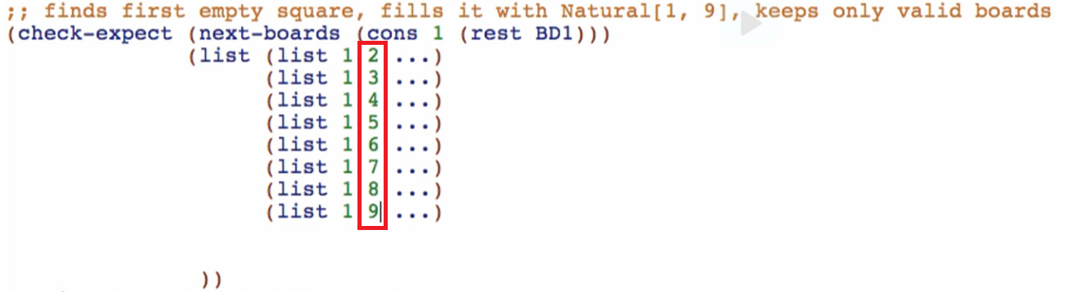

Note: rest BD1 is empty

Then populate the (…) with the original rest of the board (since we are only filling the first empty square



Then use cons so we can use rest primitive



Replace everything with this template

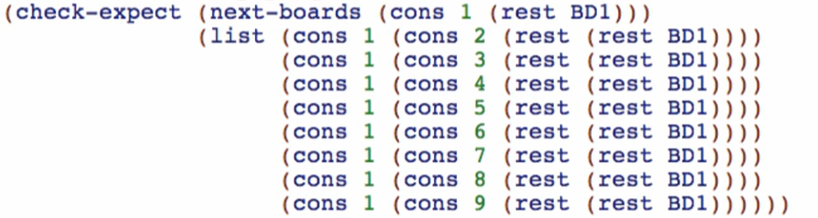

**Template**

Find the first empty square

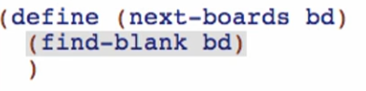

Fill the blank with Natural [1,9] that blank spot on the board

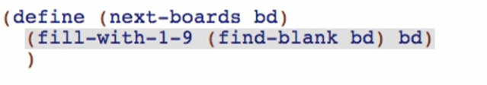

Keep only valid boards



Do the wish list entries for the 3 helpers you have done

find-blank Function

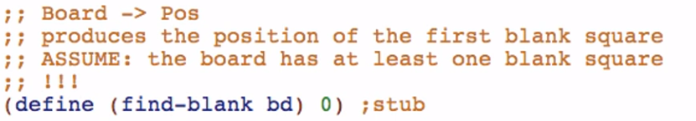

fill-with-1-9 Function

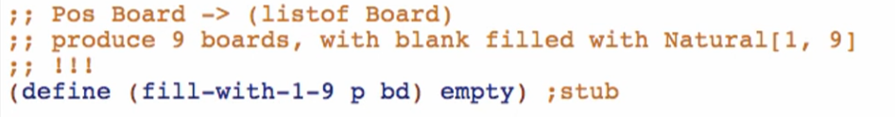

* This is like we’ve done here:
* 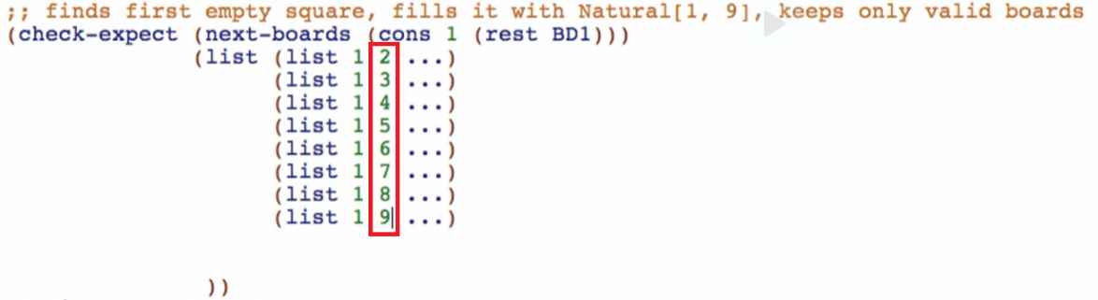

keep-only-valid

* Hint: Use filter abstract built-in function when you’ll work through the code body

